**DBMS ASSIGNMENT-2**

**1. SHOWCASE A MANY TO MANY RELATIONSHIP BETWEEN EMPLOYEE AND DEPARTMENT**

**2. COMPOSITE KEYS:**

**IN EMPLOYEE_DEPARTMENT ENTITY:**

**PRIMARY KEY (EMPLOYEE_ID,DEPARTMENT_ID)**

**3. WEAK ENTITY:**

**EMPLOYEE_DEPARTMENT**

**ERD DIAGRAM**

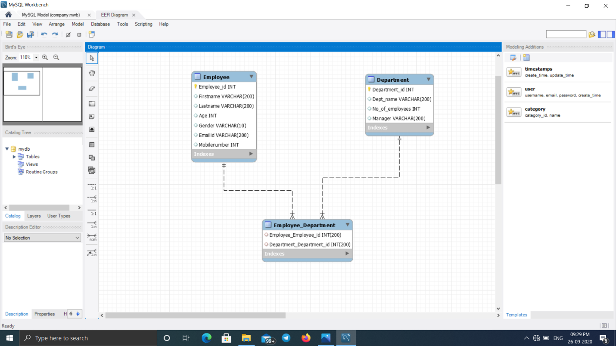

**CREATE TABLE (EMPLOYEE)**

CREATE TABLE USING PRIMARY KEY AND UNIQUE CONSTRAINT

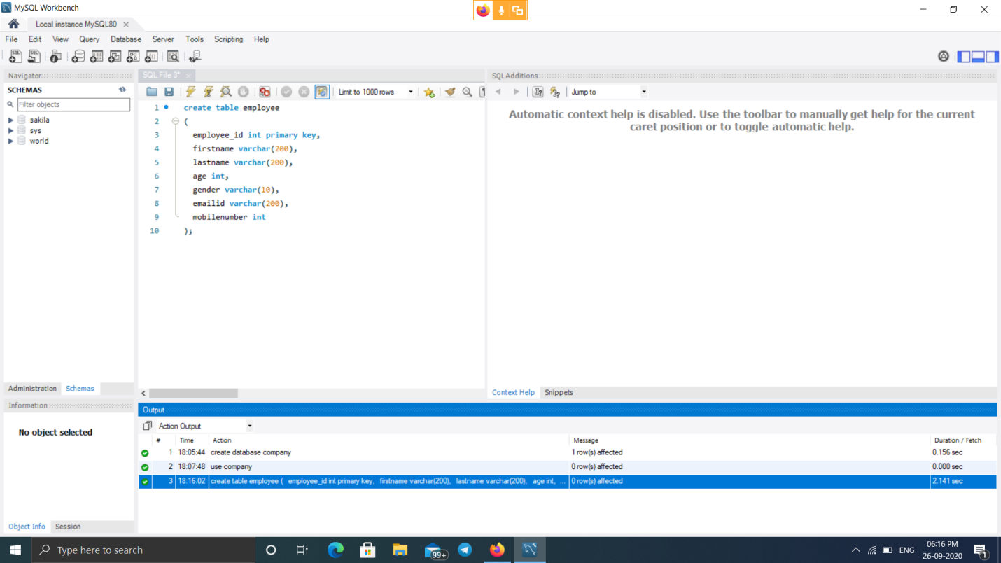

**INSERTION OF DATA INTO THE TABLE**

INSERT A DATA INTO THE TABLE USING THE COMMAND

INSERT INTO EMPLOYEE (EMPLOYEE_ID, FIRSTNAME, LASTNAME, AGE, GENDER, EMAILID, MOBILENUMBER)

VALUES();

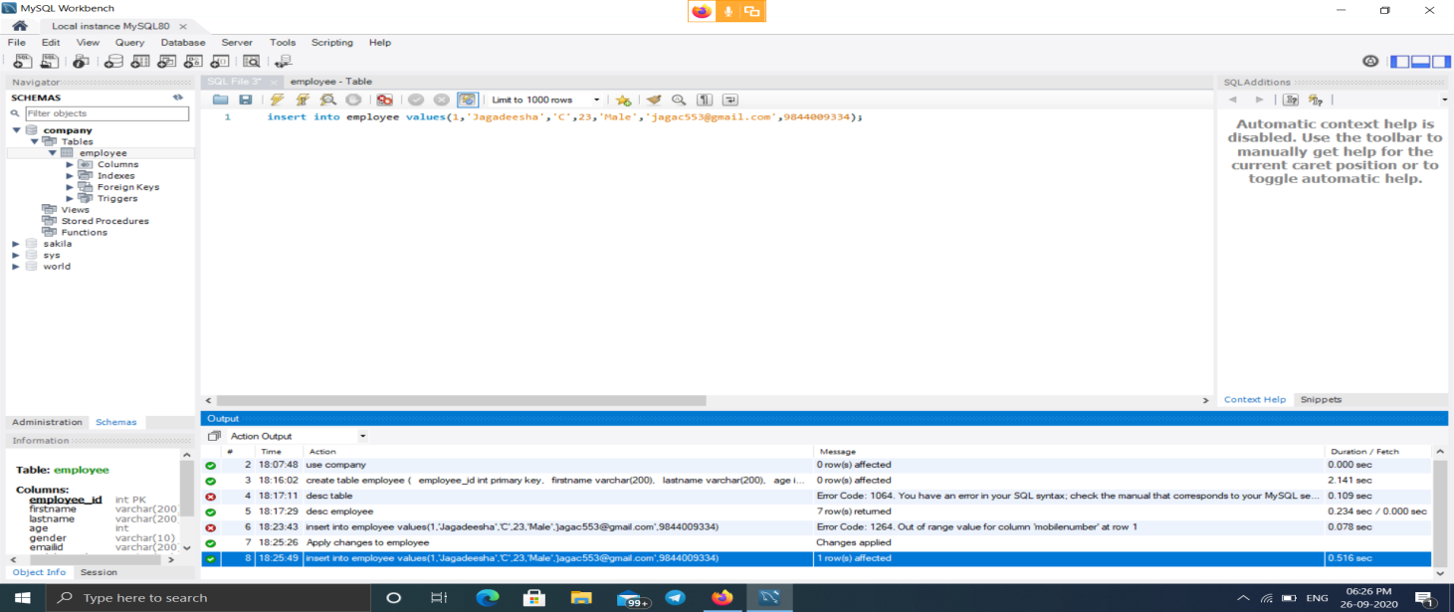

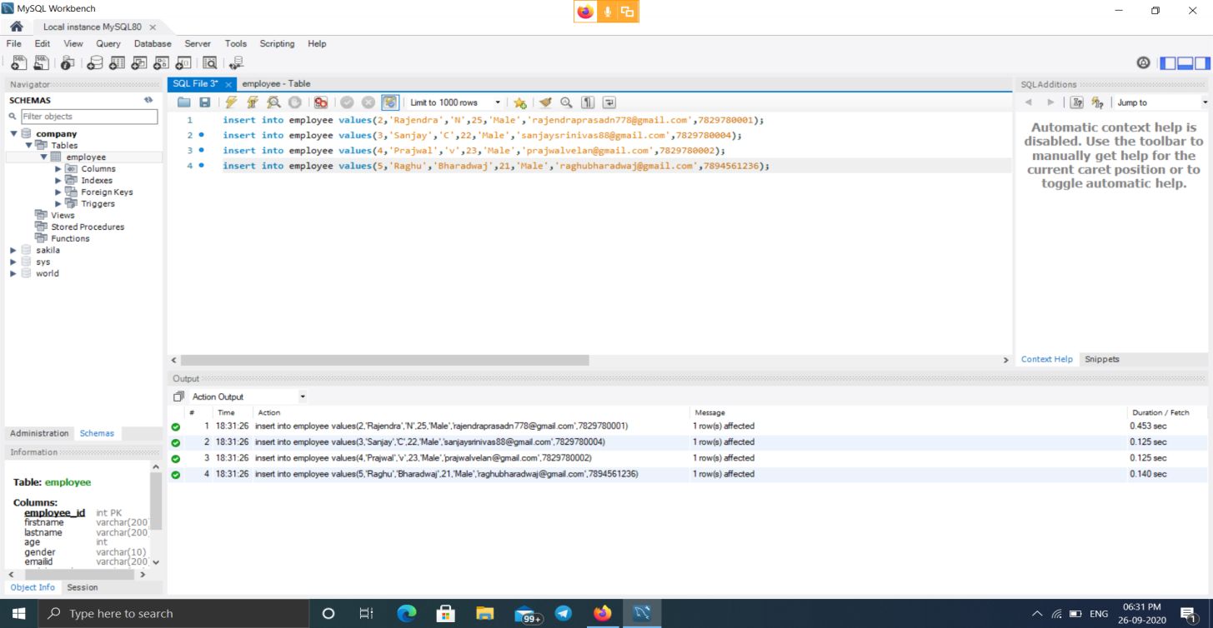

**CHECKING FOR NOT NULL VALUES**

WHEN WE TRY TO INSERT A NULL VALUE INTO THE ATTRIBUTE EMPLOYEE_ID OF STUDENT TABLE WHICH IS SPECIFIED AS NOT NULL THEN

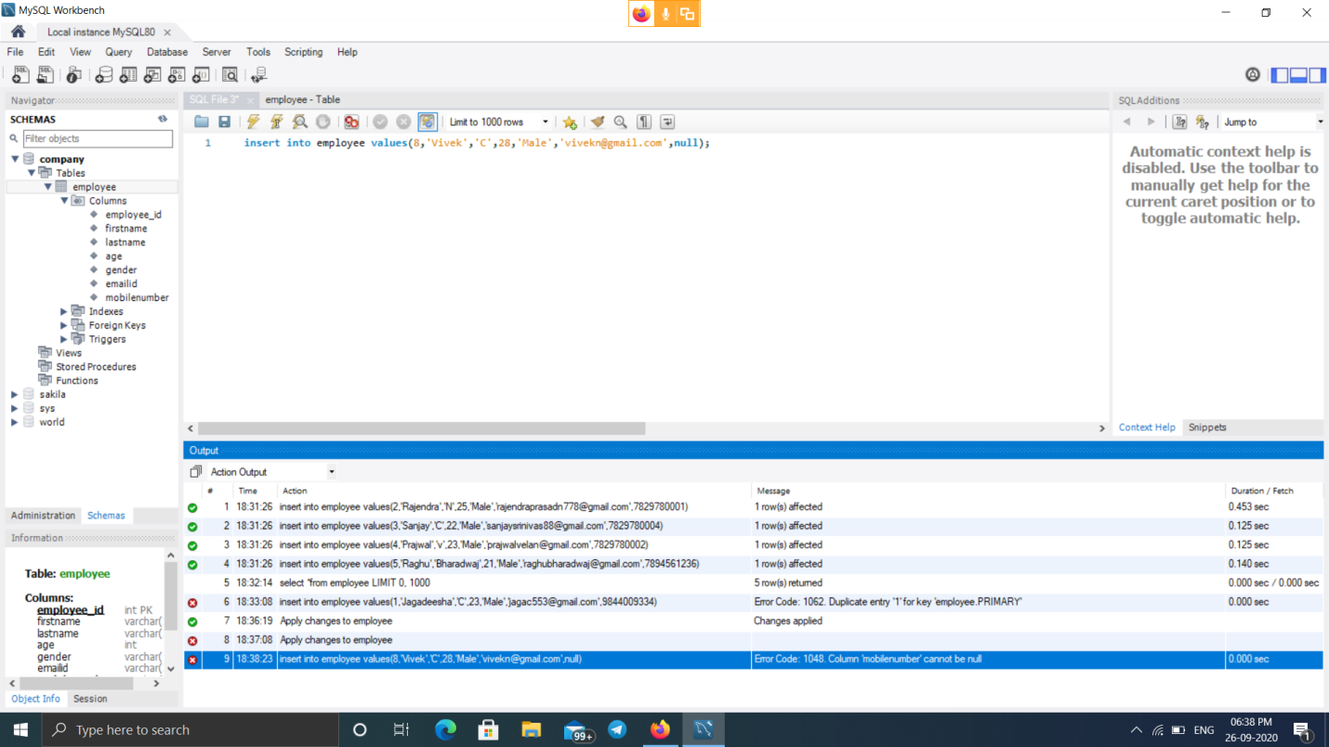

WHEN WE INSERT A DUPLICATEVALUE INTO THE ATTRIBUTE EMPLOYEE_ID OF EMPLOYEE TABLE WHICH IS A PRIMARY KEY

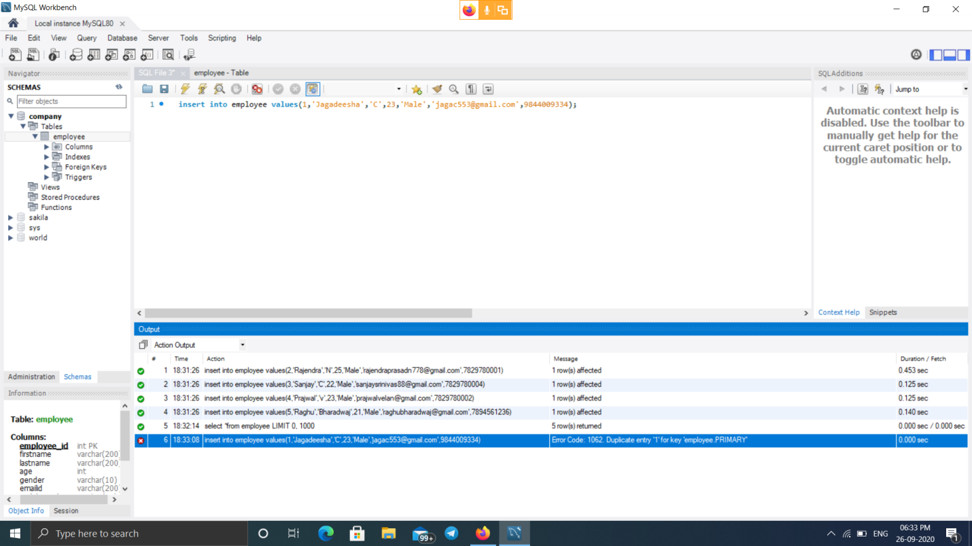

**INSERT DATA INTO THE DEPARTMENT TABLE**

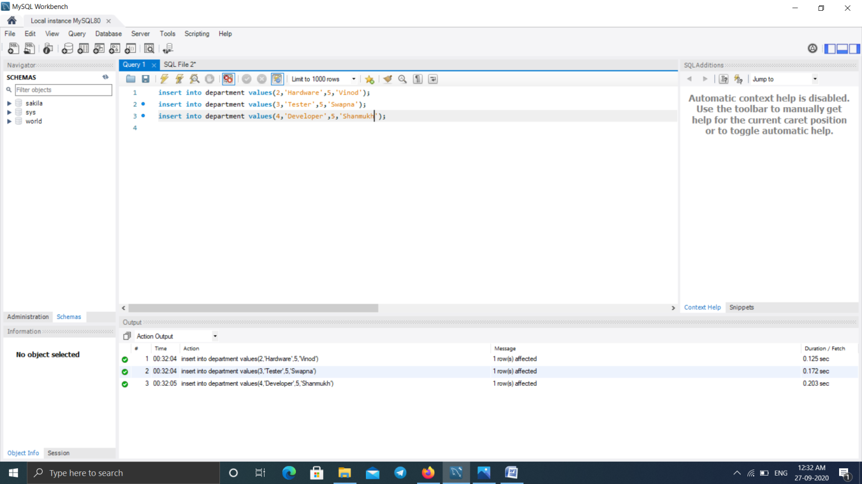

**RESULT**

WE CAN VIEW THE TABLE USING THE COMMAND

SELECT *FROM TABLE_NAME

